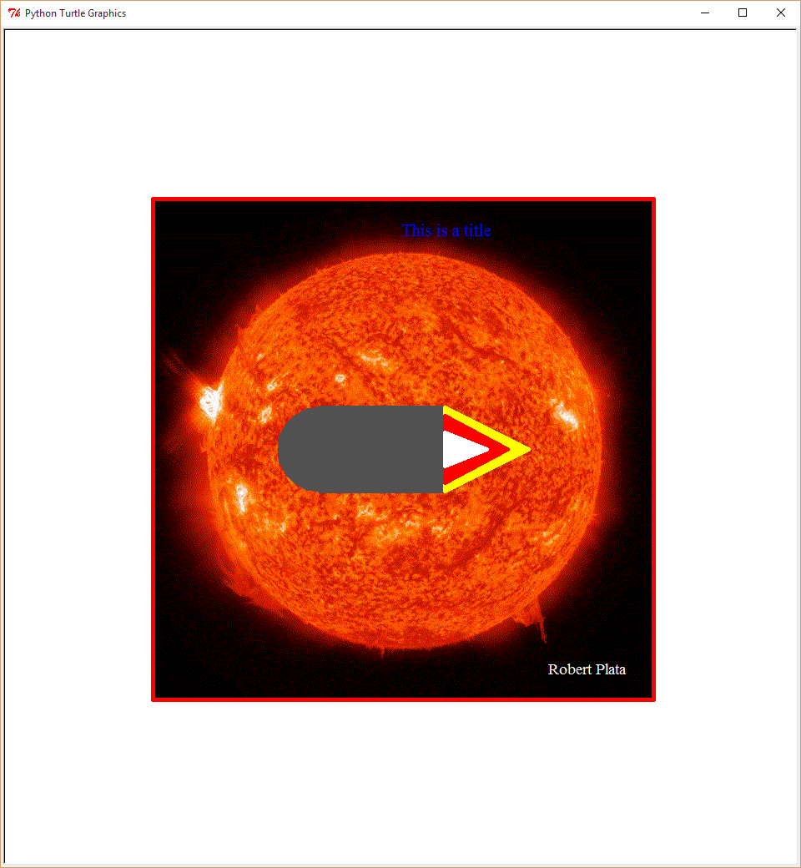

#This program is of a spaceship orbiting the sun.

#It isn't moving because the sun is so far away!

#The Image was resized to 600 by 600 pixels.

#fixed all lab requirements fixed

#3rd submit

import turtle # bring in code that lets you draw things

turtle.bgpic("sun.gif") # specify the name of your background image

turtle.resizemode("user") # if you want to let the user to resize the screen

turtle.hideturtle()

#Ask_User

turtle.penup()

turtle.goto(0, 250)

myColor=input("What color do you want? ")

turtle.color(myColor)

myTitle=input("What title do you want? ")

turtle.write(myTitle, font = ("Times", 16, "bold", "normal"))

#Turtle_Setting

turtle.hideturtle()

turtle.pensize (5) # make a thick line

turtle.speed("slow") # so you can see it better

#Picture_Frame

pictureWIDTH = 300

pictureHEIGHT = 300

turtle.color("red")

turtle.penup()

turtle.goto (-300, 300) # goes to the left top (assuming a 400x400 size screen)

turtle.pendown()

turtle.goto (pictureWIDTH, pictureHEIGHT) # goes to the right bottom (assuming a 400x400 size screen)

turtle.goto (pictureWIDTH, -pictureHEIGHT)

turtle.goto (-pictureWIDTH, -pictureHEIGHT)

turtle.goto (-pictureWIDTH, pictureHEIGHT)

#Spaceship_Nose

radius=51

turtle.penup()

turtle.goto(-100, -51)

turtle.fillcolor("#525152")

turtle.begin_fill()

turtle.circle(radius,-180) # move 180 degrees to left along edge of circle

turtle.end_fill()

turtle.circle(radius,180) # get back to bottom middle position of circle

turtle.pendown()

#Spaceship_Body

turtle.penup()

turtle.color("#525152")

turtle.goto(50, 50)

turtle.pendown()

turtle.begin_fill()

turtle.goto(-100, 50)

turtle.goto(-100, -50)

turtle.goto(50, -50)

turtle.goto(50, 50)

turtle.end_fill()

turtle.pendown()

#Propulsion_Yellow

turtle.penup()

turtle.goto(50, 50)

turtle.pendown()

turtle.color("Yellow")

turtle.begin_fill() # Begin to fill color in a shape

turtle.goto(50, -50)

turtle.goto(150, 0)

turtle.goto(50, 50)

turtle.end_fill() # Fill the shape

#Propulsion_Red

turtle.penup()

turtle.goto(50, 40)

turtle.pendown()

turtle.color("red")

turtle.begin_fill()

turtle.goto(50, -40)

turtle.goto(125, 0)

turtle.goto(50, 40)

turtle.end_fill()

turtle.pendown()

#Propulsion_white

turtle.penup()

turtle.goto(50, 20)

turtle.pendown()

turtle.color("white")

turtle.begin_fill()

turtle.goto(50, -20)

turtle.goto(100, 0)

turtle.goto(50, 20)

turtle.end_fill()

turtle.pendown()

#Robbie Plata Name Bottom Right

turtle.penup()

turtle.goto(175, -275)

turtle.pendown()

turtle.color("white")

turtle.write("Robert Plata", font = ("Times", 14, "bold", "normal") )

turtle.penup()

#Finished

turtle.done()